Yinghui Qiang
19692
MATH201 - Calculus-I
Homework Assignment #1
Due day: 5/27/2023

- Researchers measured the blood alcohol concentration (BAC) of eight adult male subjects after rapid consumption of 30 mL of ethanol (corresponding to two standard alcoholic drinks). The table shows the data they obtained by averaging the BAC (in mgymL) of the eight men.
  - Use the readings to sketch the graph of the BAC as a function of t in Excel.
  - Use your graph to describe how the effect of alcohol varies with time.

t (hours) | BAC
0 | 0
0.2 | 0.25
0.5 | 0.41
0.75 | 0.40
1 | 0.33
1.25 | 0.29
1.5 | 0.24
1.75 | 0.22
2.0 | 0.18
2.25 | 0.15
2.5 | 0.12
3.0 | 0.07
3.5 | 0.03
4.0 | 0.01

Ans:
- BAC=f(t)

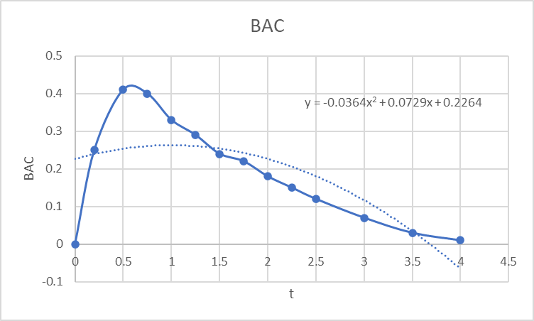

b.
BAC = f(t) t is independent value, and BAC is dependent value.
When 0 ≥ t ≤ 0.5 As t increases, BAC increases
When t > 0.5 As t increases, BAC decrease

- Find an expression for the function whose graph is the given curve in the top half of the circle $x^{2}+ {(y-2)}^{4}=4$, and then plot it in Excel or any computer language.

Ans: x²-4= (y-2)⁴

y-2 = (x²- 4) ^{¼}

y= (4-x²) ^{¼} +2

Since X² ≤ 4 x domain [-2,2] -2 ≥ x ≤ 2
When x =± -2 y =2

- In a certain country, income tax is assessed as follows. There is no tax on income up to $10,000. Any income over $10,000 is taxed at a rate of 10%, up to an income of $20,000. Any income over $20,000 is taxed at 15%.
  - Sketch the graph of the tax rate R as a function of the income I in Excel
  - How much tax is assessed on an income of $14,000? On $26,000?
  - Sketch the graph of the total assessed tax T as a function of the income I in Excel.
Ans:
- R=f(I)
Tax Rate 0% if 0 < I ≤10,000
10% if 10,000 < I ≤ 20,000
15% if I > 20,000

- If income is $14,000, Tax will be $14,000 * 10% = $1,400
If income is $26,000, Tax will be $ $26,000 * 15% = $2,400

- T=f(I)

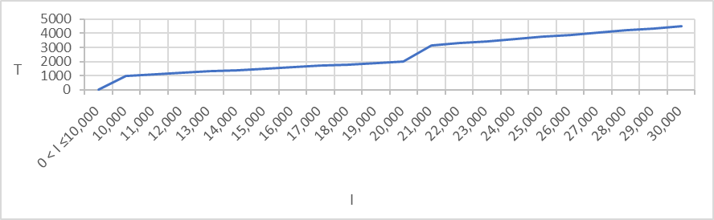
- Decide what type of function you might choose as a model for the given data as follows by selecting fitting function in Excel. Of course, before fitting, the x-y values should be created based on your observation.
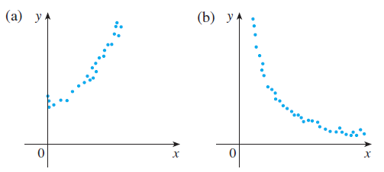

Ans:
- This is power function.
y=f(x) = x²+c
X ≥ 0
C ≥ 0

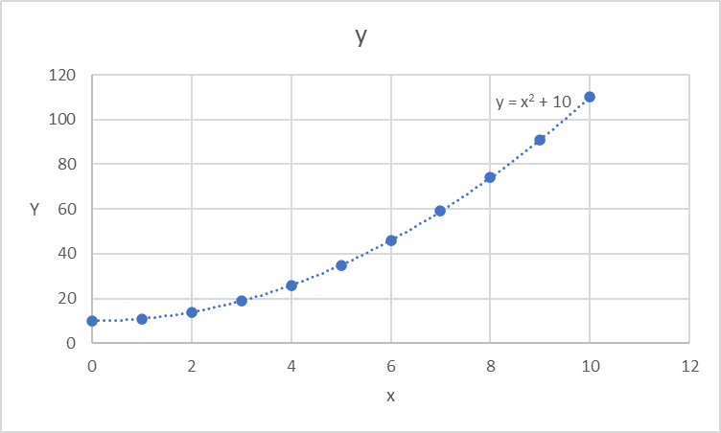

- This is power function.
Y=f(x) = c/x
The value of y is inversely proportional to the value of x.
c as a constant value x ≠ 0

y =f(x)= x⁻¹= 1/x c=1

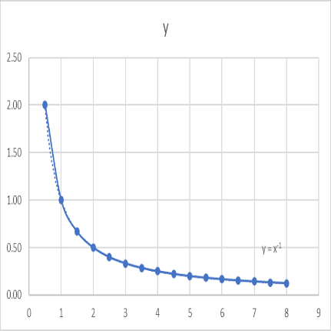
- Anthropologists use a linear model that relates human femur (thighbone) length to height. The model allows an anthropologist to determine the height of an individual when only a partial skeleton (including the femur) is found. Here we find the model by analyzing the data on femur length and height for the eight males given in the following table.
  - Make a scatter plot of the data in Excel.
  - Find and graph the regression line that models the data.
  - An anthropologist finds a human femur of length 53 cm. How tall was the person?
Femur length  (cm) | Height  (cm)
50.1 | 178.5
48.3 | 173.6
45.2 | 164.8
44.7 | 163.7
44.5 | 168.3
42.7 | 165.0
39.5 | 155.4
38.0 | 155.8
Ans:
a.

b.

c.
H=f(x)
=(178.5-173.6)/(50.1-48.3) = 4.9/1.8=2.722
2.722* (53-50.1) +178.5=186.394

Fetus length = 53CM High = 186.394CM
- The table shows the mean (average) distances d of the planets from the sun (taking the unit of measurement to be the distance from the earth to the sun) and their periods T time of revolution in years).
  - Fit a power model to the data in Excel
  - Kepler’s Third Law of Planetary Motion states that "The square of the period of revolution of a planet is proportional to the cube of its mean distance from the sun."
  - Does your model corroborate Kepler’s Third Law?

Planet | d | T
Mercury | 0.387 | 0.241
Venus | 0.723 | 0.615
Earth | 1.000 | 1.000
Mars | 1.523 | 1.881
Jupiter | 5.203 | 11.861
Saturn | 9.541 | 29.457
Uranus | 19.190 | 84.008
Neptune | 30.086 | 164.784

Ans:
a. the power function is f(x)=x^{n} T=d^{n} d > 0

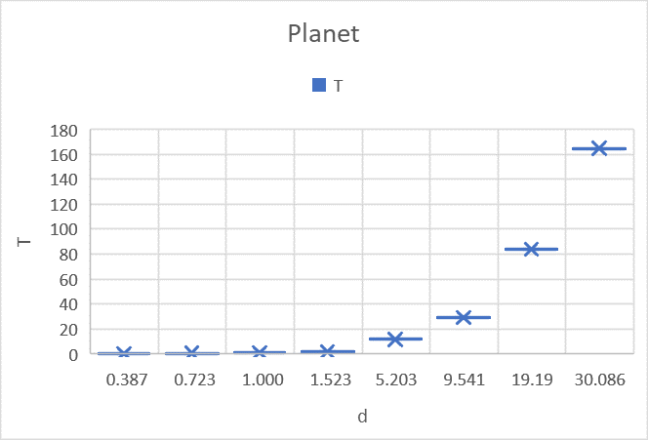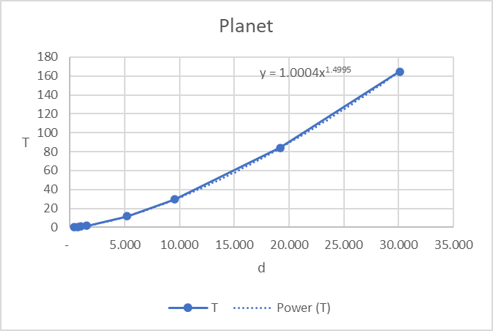

b. Kepler’s Third Law as: T ² = r³
T is time period of revolution of the planet, r is the distance of semimajor axis.

T² = d³

c. Yes. This model corroborates Kepler’s Third Law.
- How is the graph of $y=f(|x|)$ related to the graph of f(x)?
  - Sketch the graph of $y=sin(|x|)$ in Excel.
  - Sketch the graph of $y=\sqrt{|x|}$ in Excel.
Ans:
The graph of y=f(|x|) relate to the graph of f(x):
The part of the graph that lies above the x-axis remains the same; the part that lies below the x-axis is reflected about the x-axis.

When x>0 y=f(x)=f(|x|) when x<0 y = -f(x) =f(|x|)

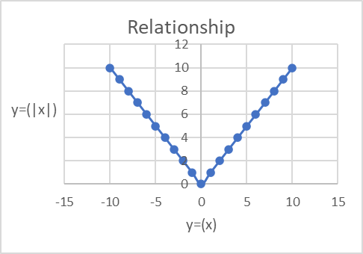

a.

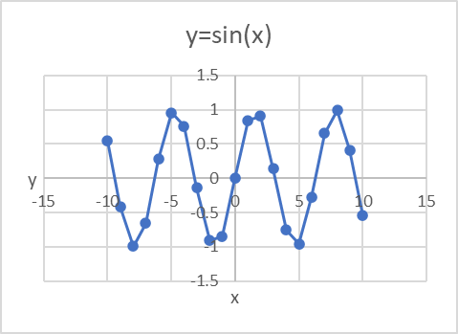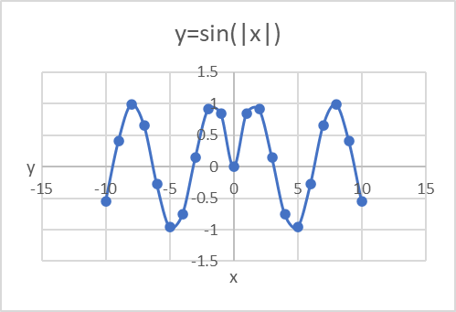
$$b. y=\sqrt{|x|}$$
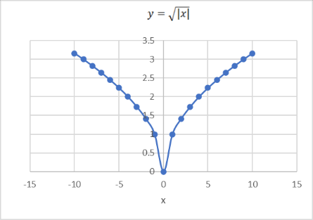

- Use the given graphs of f and g to evaluate each expression or explain why it is undefined.
  - $(g ○ f) (6)$ b. $(g ○ g) (-2)$ c. $(f ○ f) (4)$

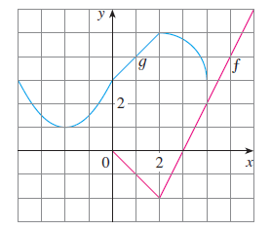
Ans:

a.
(g o f) (6) = f (g (f (6)))
y=f(x) = f (6) =6 when x axis is 6, y axis is 6
y=g(f(x)) = g(f (6)) =? Y cannot be identified.

The given graph is showing: when x=0 and x= 4 and x=-4, y=3

b.
(g o g) (-2) = f(g(g (-2)))
y=g(x) = g (-2) = 1 when x axis is -2, y axis is 1
y=g(g(x)) = g(g (-2)) = 4 when x axis is 1, y axis is 4

c.
(f o f) (4) = f (f (4))
y=f(x)=f (4)= 2 when x axis is 4, y axis is 2
y=f(f(x)) = f(f (4)) = -2 when x axis is 2, y axis is -2

